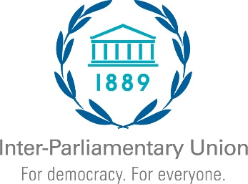 | Regional Seminar for Parliaments of the Caribbean  Jointly organized by the Parliament of Trinidad and Tobago  and the Inter-Parliamentary Union  27-29 May 2024, Port of Spain (Trinidad and Tobago)

EXPRESSION OF INTEREST

Kindly let us know if your Parliament is planning to attend the event by completing the form below and send it to postbox@ipu.org no later than 26 April 2024

□ Yes, our Parliament is interested and plans to attend the event.
□ Yes, our Parliament is interested in attending the event but will be able to confirm its participation only at a later stage.
□ Unfortunately, our Parliament will not be able to attend the event due to other commitments.

Comments: ________________________________________________________________________________________________________________________________________________________________________________________________________________________________________________________________________

Country
Parliament / Chamber
E-mail
Telephone

