Download at www.madrid143ipu.es
 | 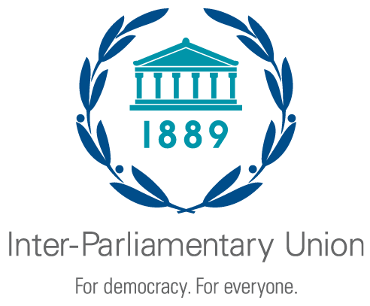 | 143rd IPU Assembly  Madrid, Spain  26-30 November 2021 |  | 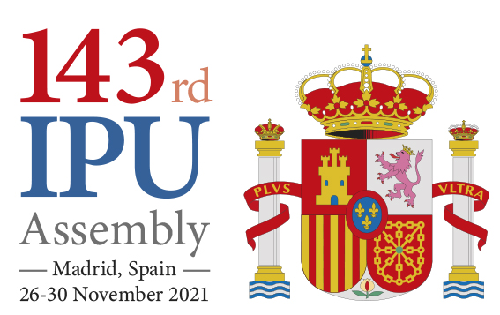

ARRIVAL/DEPARTURE AND HOTEL FORM
PLEASE COMPLETE THIS FORM AND RETURN IT NO LATER THAN 12 NOVEMBER 2021:
143rd IPU Assembly Secretariat  Carrera de San Jerónimo 36  Madrid  Spain | Tel : + 34 91 390 6352 – +34 91 390 7293  Email : ipu143@congreso.es  : ipu@viajeseci.es  Website : www.madrid143ipu.es

Parliament / Organization:

Last name (Mr./Mrs./Ms.) | First name | Accompanying person(s) | Hotel |  | Date | Time | Special requirements
 |  |  |  | Arrival
 |  |  |  | Departure
 |  |  |  | Arrival
 |  |  |  | Departure
 |  |  |  | Arrival
 |  |  |  | Departure
 |  |  |  | Arrival
 |  |  |  | Departure
 |  |  |  | Arrival
 |  |  |  | Departure
 |  |  |  | Arrival
 |  |  |  | Departure

Sent by
Name :
Title :
Parliament/Organization :
Telephone : Email :

The Spanish Parliament is not in a position to provide transport from the airport to the hotels.

