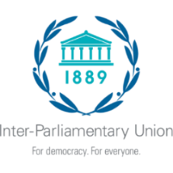

Second Regional Seminar for African Parliaments on Achieving the Sustainable Development Goals

Djibouti 5-7 December 2022

Organized jointly by the National Assembly of Djibouti
and the Inter-Parliamentary Union

INDIVIDUAL HOTEL RESERVATION FORM AND ITINERARY

Full name:……………………………………………………………………………………

Parliament: ……………………………………………………………………………………

Hotel name: …………………………………………………………………………………………

Category of room chosen: …………………………………………………….…………………...

TRAVEL ITINERARY

Date of arrival: ………………………… Hour of arrival: …………….……

Flight No: ………………………… Coming from: ……………….….

Date of departure: ……………… Hour of departure: ………………
Flight No: …….……………

Signature and date: …………………………….………………………..……………………
Kindly complete and send to the hotel, no later than 30 November 2022, with copy to:

National Assembly of Djibouti  National Assembly  B.P. 138  Djibouti  Seminar Secretariat  Mr. Idriss Mohamed Ahmed, Director of the  Office of the President  Tel: +253 77 87 27 87  e-mail: idrisshoulay77@gmail.com  malma2@hotmail.fr  National Assembly Protocol:  malma2@hotmail.fr  sordak_2@hotmail.com; ahmedwaberi@hotmail.fr  hellaka3@gmail.com | Inter-Parliamentary Union  Chemin du Pommier 5  C.P. 330  1218 Le Grand-Saconnex  Geneva, Switzerland  Tel: +41 22 919 4150  Fax: +41 22 919 4160  E-mail: postbox@ipu.org

