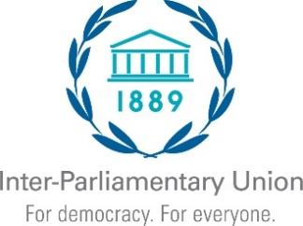 | Interregional Seminar on parliamentary capacity building and the further implementation of the Sustainable Development Goals  Stronger inter-parliamentary exchanges  for a better achievement of the SDGs  6-8 July 2023 - Beijing (China)

One form per participant
To be returned no later than 16 June 2023

Registration Form
Country
Ms. Mr. Mrs.
First name |  |  | Surname
Parliament / Chamber
Function | Member of Parliament | Senator |  |  | Aide or staff
Full title
Office E-mail
Personal E-mail

For parliamentarians only

Please list up to three parliamentary committees to which you belong
1
2
3

Telephone:
Email: |  |  | I would like to receive IPU updates

Date: |  | Signature:

Please return this form to:

Inter-Parliamentary Union
Chemin du Pommier 5, Case postale 330
1218 Le Grand-Saconnex
Geneva, Switzerland
Telephone: +41 22 919 41 50 / Fax: +41 22 919 41 60
Email: postbox@ipu.org

